Test Case: tc001_SPX_Dev5_Crear_Solicitud_Articulo_Almacen
Step 1 - Enter username and password and click to button Enter : Credentials Entered
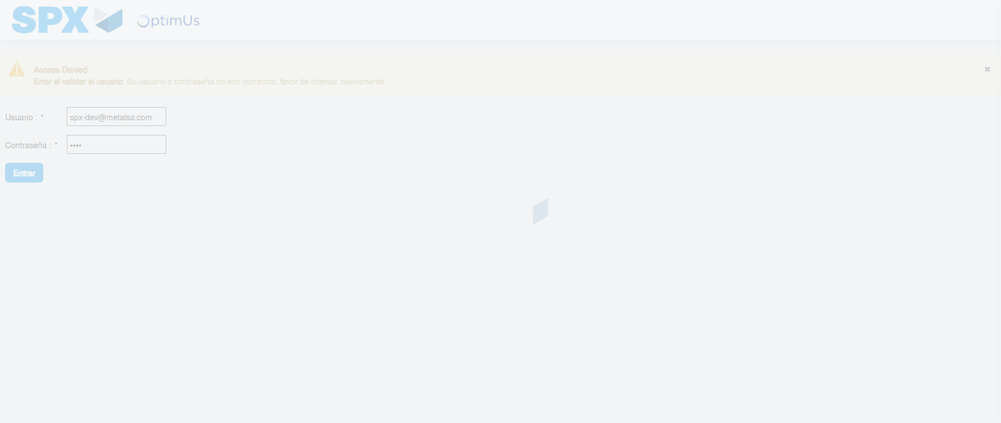Image file-name: QC_Testing-tc001_SPX_Dev5_Crear_Solicitud_Articulo_Almacen-1787840444331

Step 2 - Select to UEN and Access to Request for a New Inventory Item : UEN Correctly selected and Correct access
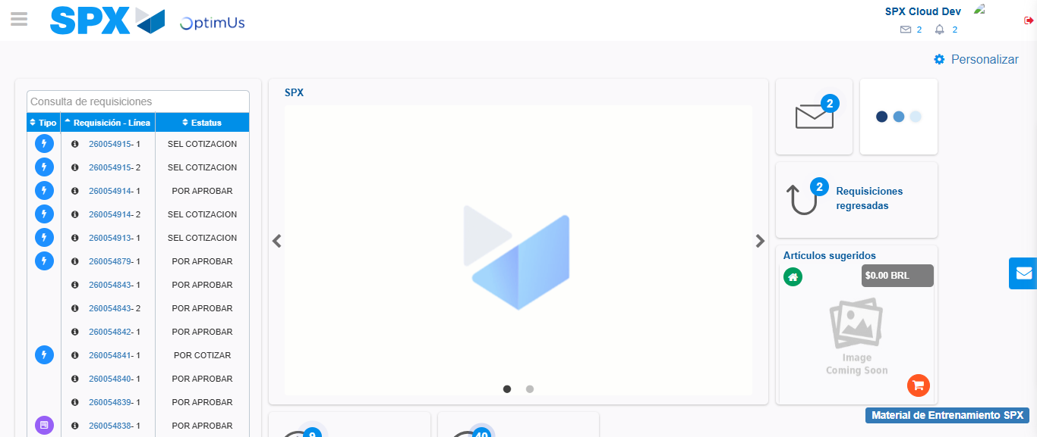Image file-name: QC_Testing-tc001_SPX_Dev5_Crear_Solicitud_Articulo_Almacen-1787840470838

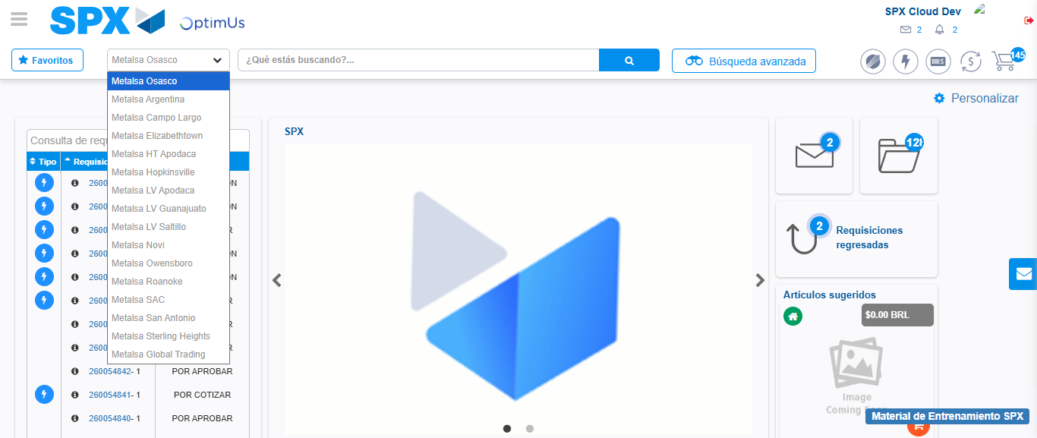Image file-name: QC_Testing-tc001_SPX_Dev5_Crear_Solicitud_Articulo_Almacen-1787840532134

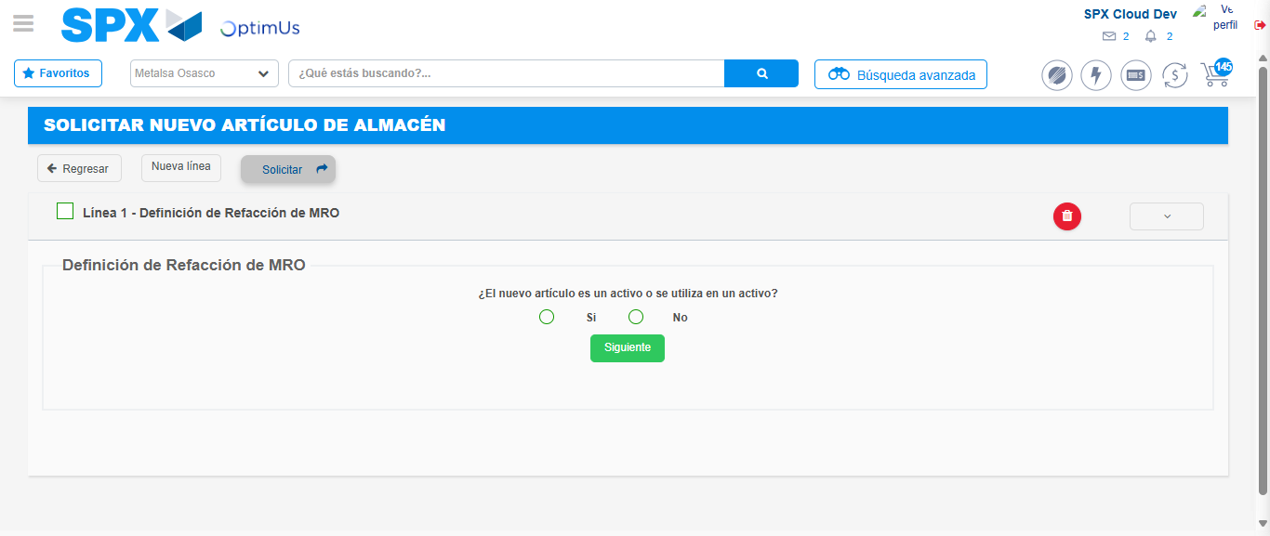Image file-name: QC_Testing-tc001_SPX_Dev5_Crear_Solicitud_Articulo_Almacen-1787840538925

Step 7 - Return to Main Page SPX : Return to Main Page SPX
Image file-name: QC_Testing-tc001_SPX_Dev5_Crear_Solicitud_Articulo_Almacen-1787840470838

Image file-name: QC_Testing-tc001_SPX_Dev5_Crear_Solicitud_Articulo_Almacen-1787840532134

Image file-name: QC_Testing-tc001_SPX_Dev5_Crear_Solicitud_Articulo_Almacen-1787840538925

Image file-name: QC_Testing-tc001_SPX_Dev5_Crear_Solicitud_Articulo_Almacen-1787840541616

Image file-name: QC_Testing-tc001_SPX_Dev5_Crear_Solicitud_Articulo_Almacen-1787840541775

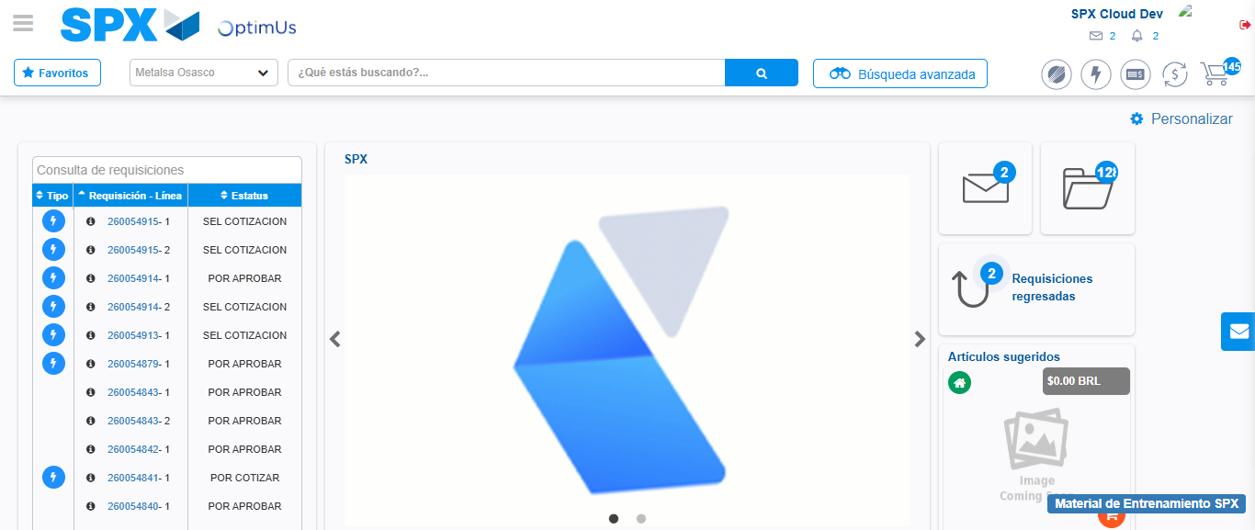Image file-name: QC_Testing-tc001_SPX_Dev5_Crear_Solicitud_Articulo_Almacen-1787840563358

Step 8 - Log Out : Log Out SPX
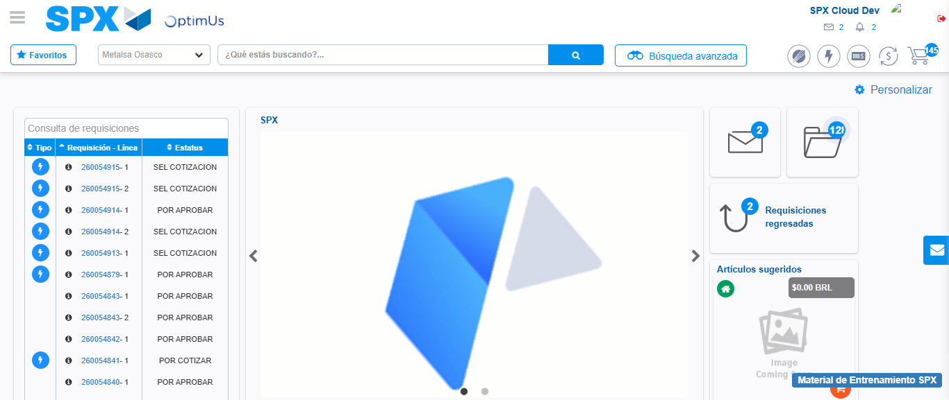Image file-name: QC_Testing-tc001_SPX_Dev5_Crear_Solicitud_Articulo_Almacen-1787840563683

